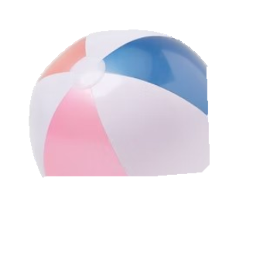


Contact - 9112345771
11 Street, Best Party Club, Sunshine North , 3022
MUSIC – FOOD – DRINK
SUMMER
PARTY

YOU ARE INVITED TO

